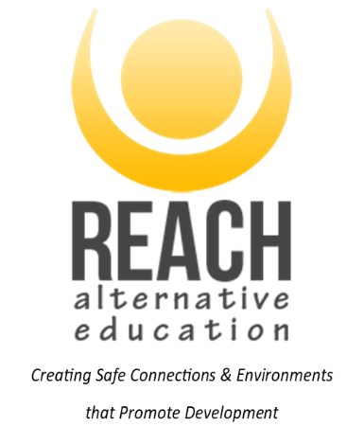
PARENT/CARER CONSENT FORM FOR
ALTERNATIVE PROVISION
This two-page form should be read with the accompanying information/letter about the placement. All sections must be completed. Please answer with details or by stating N/A (not applicable) for the medical and dietary sections. This information is requested to enable staff to be fully informed and act in the interest of all participants.
GENERAL INFORMATION
Name of Young Person: …………………………………………………………………………………………………………………………………
Date of Birth: …………………………………………………………………………………………………………………………………………………
School / Establishment: ……………………………………………………………………………………………………………………………….
Date(s) of placement: September 2024 – July 2025
Placement information: REACH Alternative Education placement, forming part of education provision for the student. Youth Work team, providing one to one and group placements, offsite from school, using one of REACH’s bases across Somerset. Using Youth Workers cars as transport, and a range of activities including group work, mentoring, life skills, outdoor education session, visits to sites/public amenities and activity providers across the South West. Please contact REACH directly to discuss activities and programme content/should you wish to arrange a visit.
MEDICAL & DIETARY INFORMATION
If the Young Person has any condition or impairment that may require specific management, medical treatment and/or medication during he outlined activity/trip/visit please detail:
………………………………………………………………………………………………………………………………………………………………………
………………………………………………………………………………………………………………………………………………………………………
If the Young Person has any allergies or is allergic to a medication please supply details:
………………………………………………………………………………………………………………………………………………………………………
………………………………………………………………………………………………………………………………………………………………………
If the Young Person has had any recent illnesses, accidents or injury which staff should be aware of please supply details:
………………………………………………………………………………………………………………………………………………………………………
………………………………………………………………………………………………………………………………………………………………………
Date of the Young Persons last anti-tetanus injection: …………………………………………………………………………………….
Can the Young Person Swim: Yes / No / Weak Height: ……………………………
If the Young Person has any essential dietary requirements, please supply details below:
………………………………………………………………………………………………………………………………………………………………………
………………………………………………………………………………………………………………………………………………………………………
EMERGENCY CONTACT
Name of Parent / Carer: ………………………………………………………………………………………………………………………………….
Address: …………………………………………………………………………………………………………………………………………………………
Emergency Telephone Number
Daytime: …………………………………………………………………… Evening: …………………………………………………………………….

Please provide two alternative emergency contacts should parent/carer not be available:

- Name: ………………………………………………………… Relationship to Young Person: ………………………………
Address: ………………………………………………………………………………………………………………………………………….
Emergency Telephone Number
Daytime: …………………………………………………………………… Evening: …………………………………………………………………….

- Name: ………………………………………………………… Relationship to Young Person: ………………………………
Address: ……………………………………………………………………………………………………………………………………………………….
Emergency Telephone Number:
Daytime: …………………………………………………………………… Evening: …………………………………………………………………….

If you feel that further details or a discussion is required regarding any of the information that you have supplied, please contact REACH prior to the start of the placement

DECLARATION
I understand that all reasonable care will be taken of the Young Person during the placement and that they will be under an obligation to follow all directions and instructions given and observe all rules and regulations governing the placement and activities.
I understand that if the Young People is a cause of danger to themself or to others, then they may be sent home early from the placement day. In such a situation you and the school will be notified first.
I understand the extent and limitations of the insurance cover provided and whilst the establishment staff in charge of the group will take all reasonable care, they cannot necessarily be held responsible for any loss or damage suffered by the Young Person during the visit. I understand that all visits are covered by public liability insurance, and I can contact the school/REACH if I require further details. Please note that personal accident cover is not included in the cover provided by the school/REACH. It is the responsibility of the Parent/Carer to take out suitable personal accident cover, should they require it.
I agree to the Young Person receiving medical care if required. This would include first aid and any emergency dental, medical or surgical treatment as considered necessary by the medical authorities present in the best interest of your Young Person.
I give permission for the Young Person to be photographed/filmed during this placement (for possible use in displays/presentations, marketing materials for sending to schools and our website.
If you do not give permission for photos to be taken, please tick this box.
Having been informed through the details supplied. I consent to the Young Person taking part in this placement. This includes consent for them to take part in all the outdoor activities, group work, one to one support and car travel opportunities supplied by REACH.

Full name of Parent/Carer (print name please): ……………………………………………………………………………………………….

Signed: …………………………………………………………………………………………………. Date: ………………………………………………

EXPLANATORY NOTES
This for serves several important functions:
- It confirms your knowledge of and your agreement to the Young Person’s participation in the placement.
- It gives the supervising staff immediate information on how to contact you in an emergency.
- It contains information about the Young Person together with your consent to medical treatment if required.
- It advises you that REACH will NOT necessarily be legally liable for every type of loss suffered by a child whilst on a visit.
- The completion and returning of this form are essential to enable the Young Person to participate in the placement.
- If you wish to discuss any of the contents of this form, please contact us.

